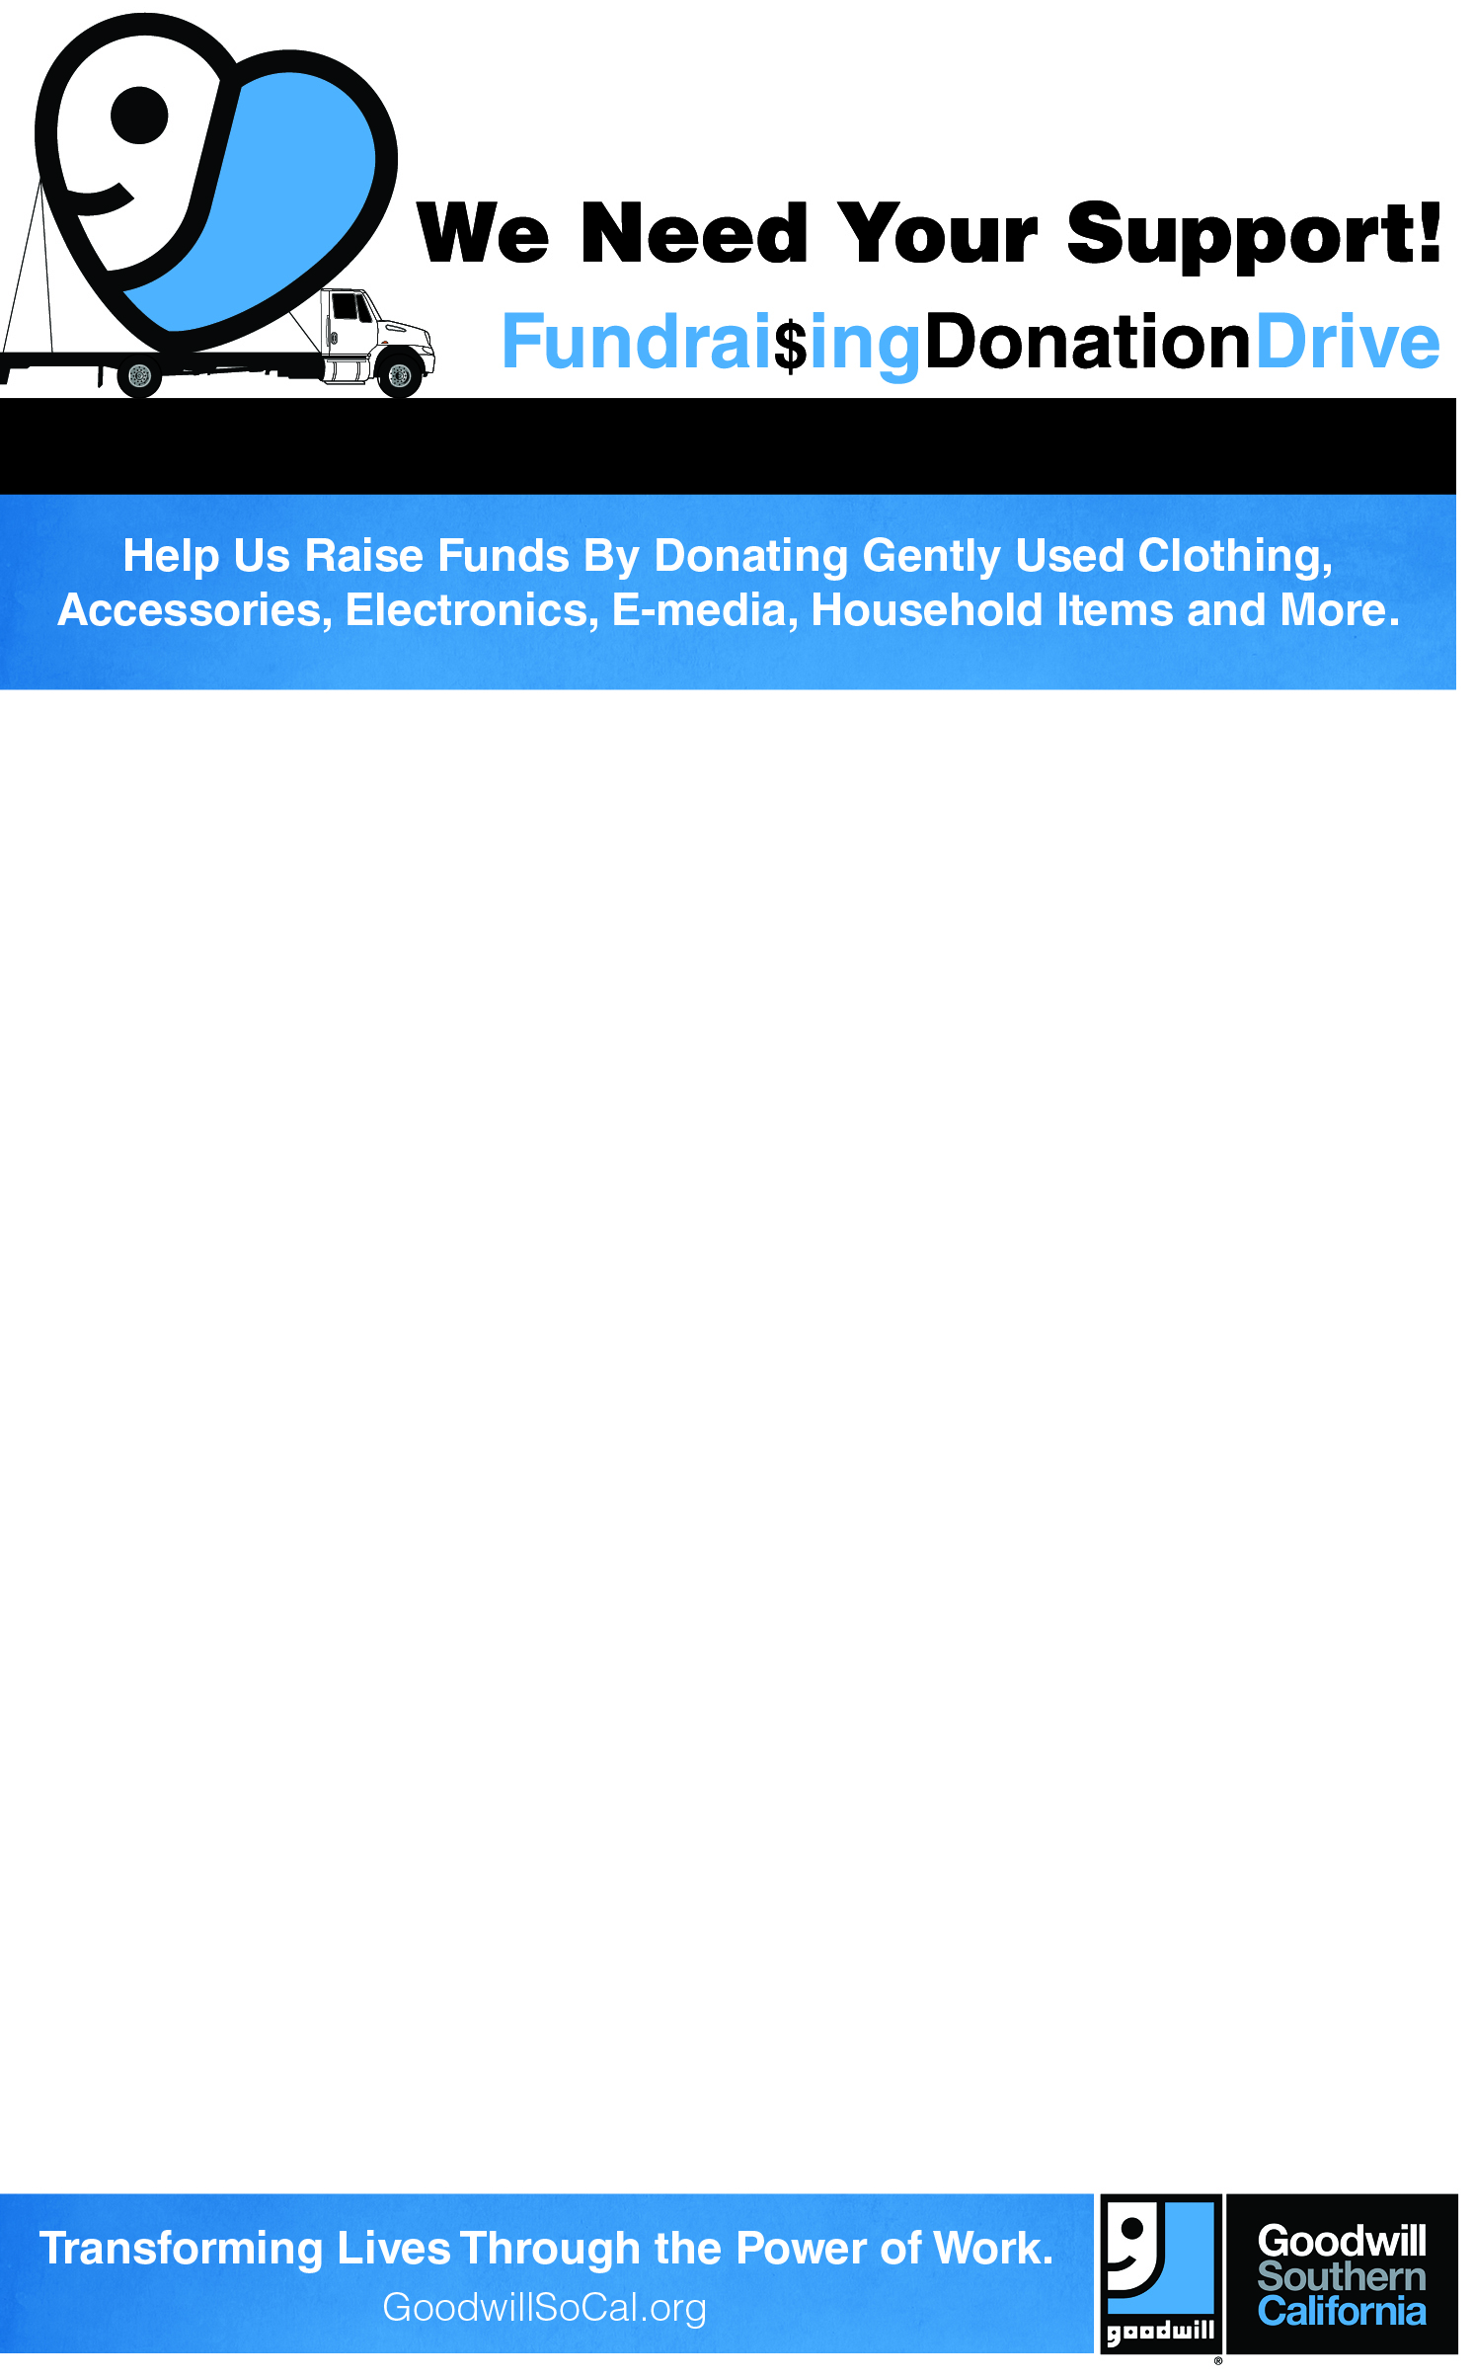

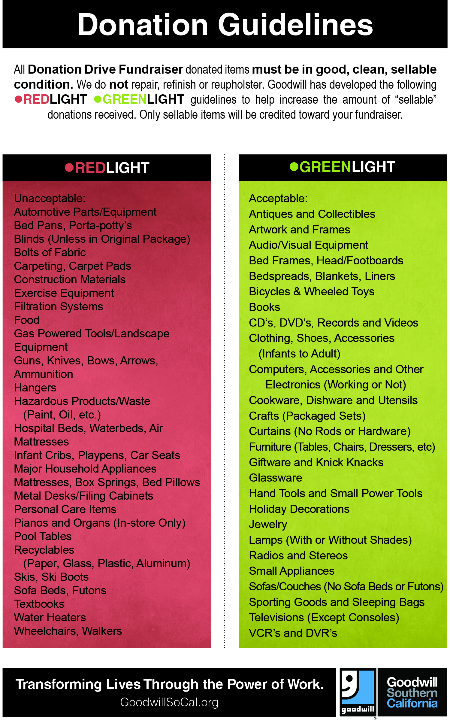

Foster & Banks Walk in
Faith Foundation
has partnered with Goodwill Southern California to raise funds, as well as support Goodwill’s mission of enhancing the quality of life for people with disabilities or other disadvantages through education, training and job placement services. That’s
Good for Everyone!

Please Drop-off Your Donations:
December 1, 2012
[9:00am-3:00pm]
Budlong Elementary School: 5940 S. Budlong Avenue, Los Angeles CA 90047

For Pick-up Please Call:
[Phone Number]

 Organization Logo Here]
Foster & Banks Walk in Faith Foundation earns money for every trailer full of donated items. Foster & Banks Walk in Faith Foundation thanks you, Goodwill thanks you, and your closet, basement, attic and garage really, really thank you!
[www.walkinfaithfoundation.com]
Call us to have donations picked up: 310-885-1409

